**Md Yaseen**

**Day 5 Assignment**

**Assignment-1:**

**Initialize a new Git repository in a directory of your choice. Add a simple text file to the repository and make the first commit.**

**Solution :**

**Step-1:** Login to the github.com, click on repositories.

**Step-2:** Click on New, and give the meaningful repository name and click on Create Repository.

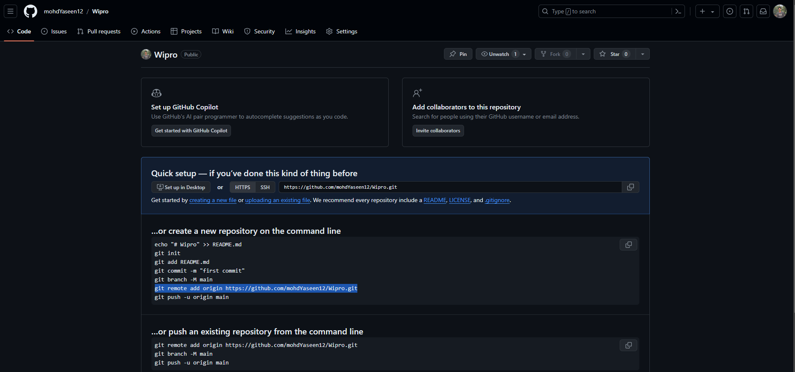

**Step-3:**  Create a folder in local system and it in command prompt.

**Step-4:** use *git init*  , it will initialise local folder to a local git repository.



**Step-4:** *git remote add origin* [*https://github.com/mohdYaseen12/Wipro.git*](https://github.com/mohdYaseen12/Wipro.git)

This will connect local git repository to remote git repository.



**Step-5:** Add a text file in the folder. Use *git add .* to add the file in the local repository.

**Step-6:** *git commit -m “first commit”* this will save the text in the local repository only. And now the file is ready to be uploaded to remote location.



**Step-7:** *git push origin master* This will upload/ push the file to remote github repository. And this file will be reflected by refreshing the page.

Assignment.txt file uploaded to remote repository.

**Assignment-2:**

**Branch Creation and Switching**

**Create a new branch named 'feature' and switch to it. Make changes in the 'feature' branch and commit them.**

**Solution:**

Steps to achieve above said task.

**Step-1:** My friend Mehul collaborated with me for this assignment, send me an invitation.



**Step-2:** Cloning his repository Assignment_Training to my local machine.

**Step-3:** Creating a branch naming as *yaseen_dev* and switching to *yaseen_dev* branch by using *git checkout* command.

**Step-4:** Adding a text file *yaseen_dev_v1.txt* file in my local machine in the repository clone location.

**Step-5:** Now using *git add .* and *git commit -m*  command to add the *yaseen_dev_v1.txt* file to the local repository.And finally, using *git push origin yaseen_dev* command to push the file to the remote branch repository.

And now the push reflects in the branch on the remote repository.

**Step-6:** Now creating a pull request to add my file to main/master branch in the remote repository.

**Step-7:** Merging the file to the main/master branch after getting approval by the administrator in this demo I am also an admin.

Using *git merge yaseen_dev.*

**Step-8:** Now commit the changes made and push to the remote repository.

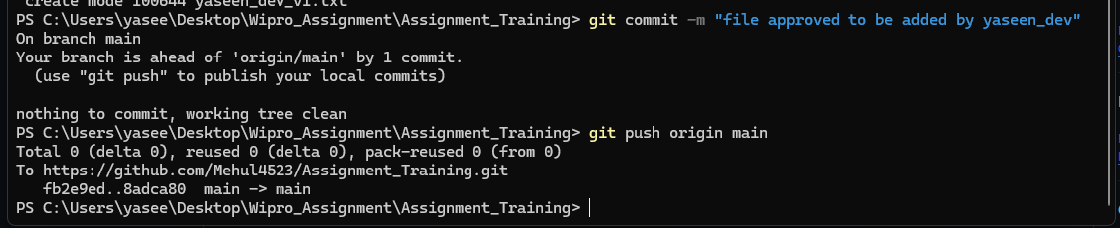

And after this the added file will reflect in the main branch.



**Step-9:** Deleting the *yaseen_dev* branch from the local repository.



But the branch is not deleted from the remote repository.



**Step-10:** Deleting the *yaseen_dev* branch from the remote repository.



Now the *yaseen_dev* branch is deleted from the remote repository.

